ISLAMIC UNIVERSITY OF TECHNOLOGY
Organization of Islamic Cooperation
Board Bazar, Gazipur

Laboratory Report
CSE 4512

Title: Configuring IPv6 addressing scheme in a network topology and configuration of Inter VLAN routing with IPv6.
Objective:
- Configure IPv6 on Routers, Servers and Clients.
- Test and Verify IPv6 Network Connectivity.
- Configure IPv6 Inter-VLAN routing.
Devices/Software Used: Cisco Packet Tracer
Theory:
IPv6 was created to address the quickly diminishing address space of IPv4. With $2^{128}$ addresses theoretically at its disposal, IPv6 is expected to prove sufficient for the foreseeable future.
The 128 bits are expressed in colon hexadecimal notation, as eight groups of four hexadecimal numbers separated by colons, each group representing 16 bits, e.g. $2001 :0DB8 :85A3 :0000 :0000 :8A2E :0370 :7334/64$. There is a network identifier and an interface identifier, with each taking up 64 bits by default. The CIDR notation at the end of the address denotes the number of bits being used for the network identifier.
A more concise representation is generally used, with the leading zeroes in each group removed and consecutive groups of 0s represented as a double colon. The latter shorthand is only used once per address to avoid ambiguity. The previous example would thus be represented as $2001 :DB8 :85A3∷8A2E :370 :7334/64$.
For every IPv6 address, there is also a corresponding address called a link-local address. This is also an IPv6 address with the fixed prefix $FE80∷/10$. This address is only valid within the broadcast domain of the host and is used as the default gateway for the host. It is also used during the neighbour discovery protocol and automatic address configuration.
Diagram of the experiment:
Task #01:
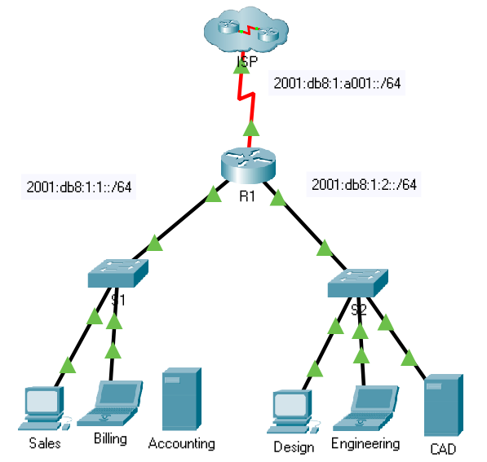

Task #02:
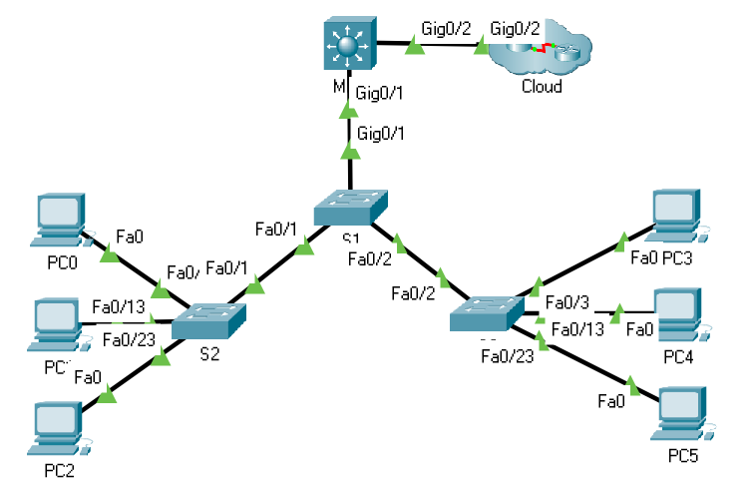

Working Procedure:
TASK #01:
- IPv6 addressing was enabled on R1 and the required IPv6 address and link-local address were assigned to the GigabitEthernet0/0, GigabitEthernet0/1 and Serial0/0/0 interfaces.
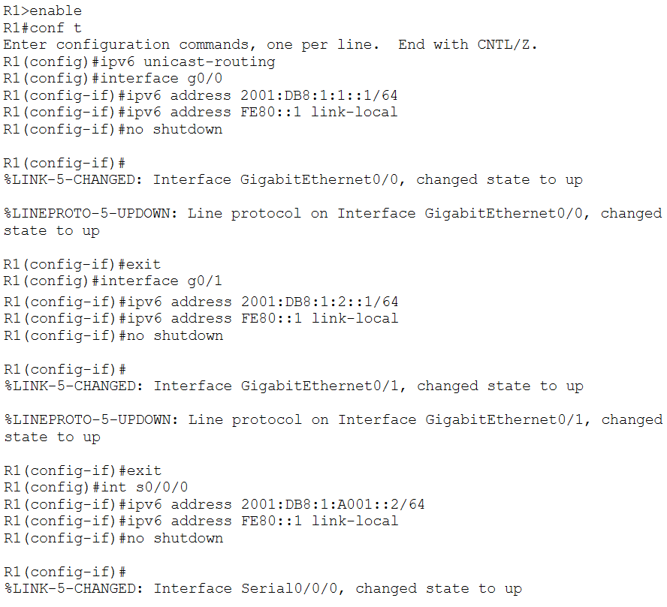

- The assigned IPv6 addresses were verified.
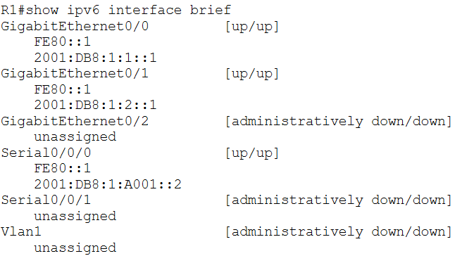
- An IPv6 address and a default gateway were assigned to the Accounting Server.
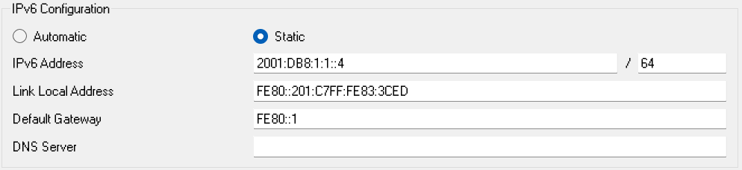
- An IPv6 address and a default gateway were assigned to the CAD server.
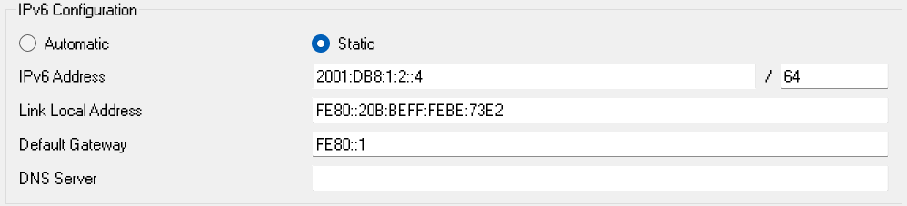

- IPv6 addresses and default gateways were assigned to the clients.
Sales:
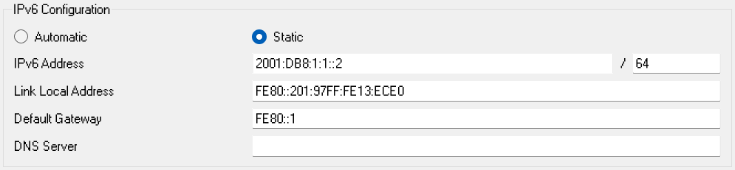
Billing:
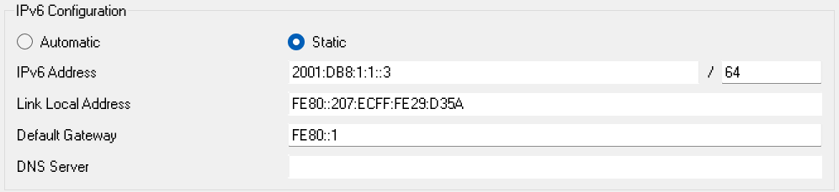
Design:
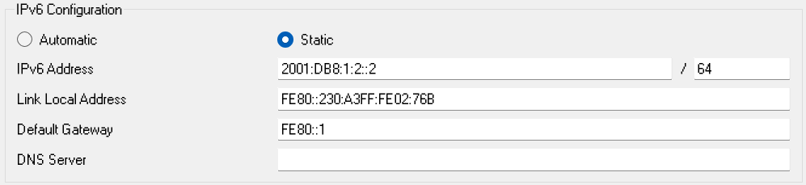
Engineering:
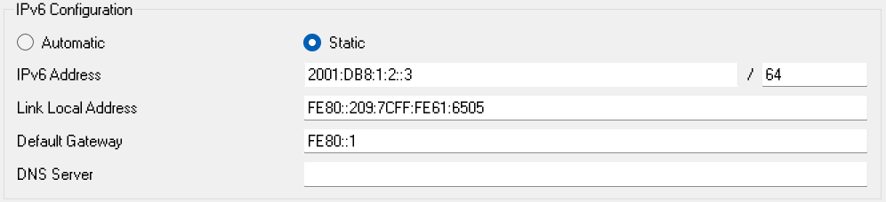

- It was verified that the Accounting and CAD websites were reachable from the clients.
Accounting:
Note that the Request Timeout occurs because the Account server is not connected to the network. This cannot be fixed since the required permissions to create new connections have not been granted.
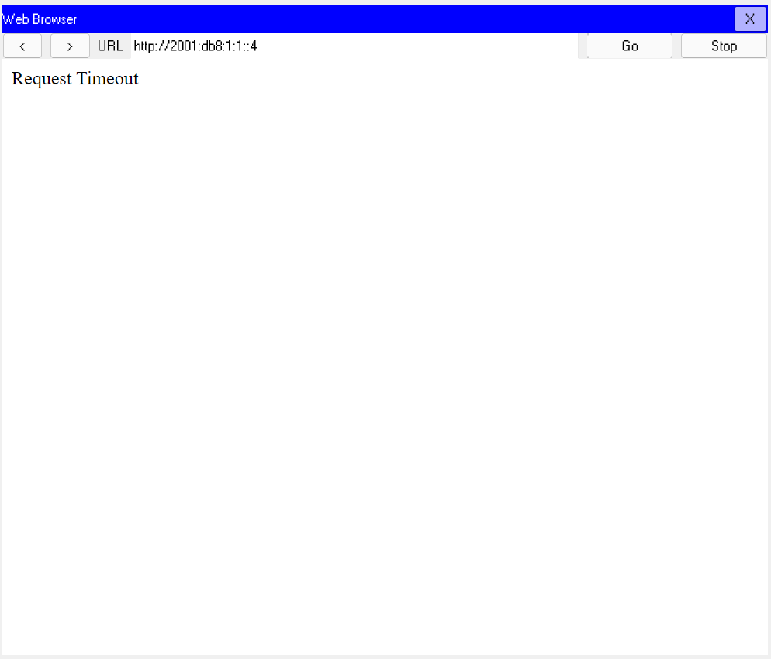

CAD:
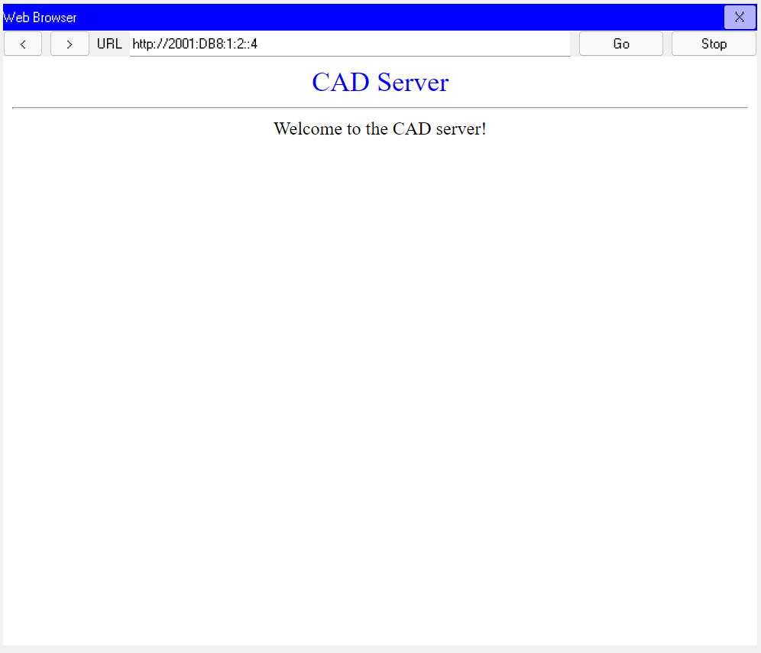
- It was verified that the ISP was reachable from the clients.
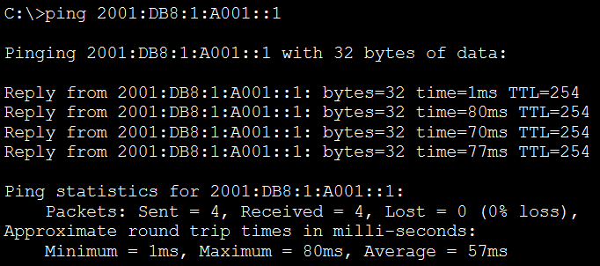
TASK #02:
- IPv6 was enabled on the MLS and an IPv6 address was assigned to VLANs 10, 20 and 30 and the G0/2 interface.
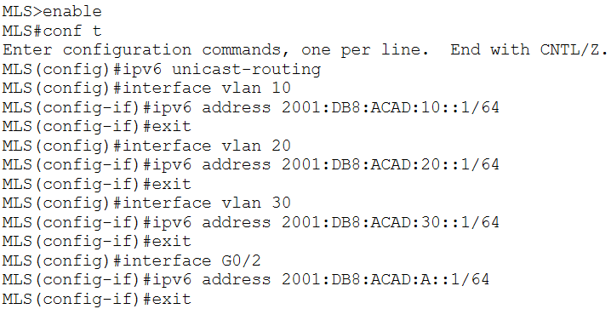
- The IPv6 connected networks were verified.
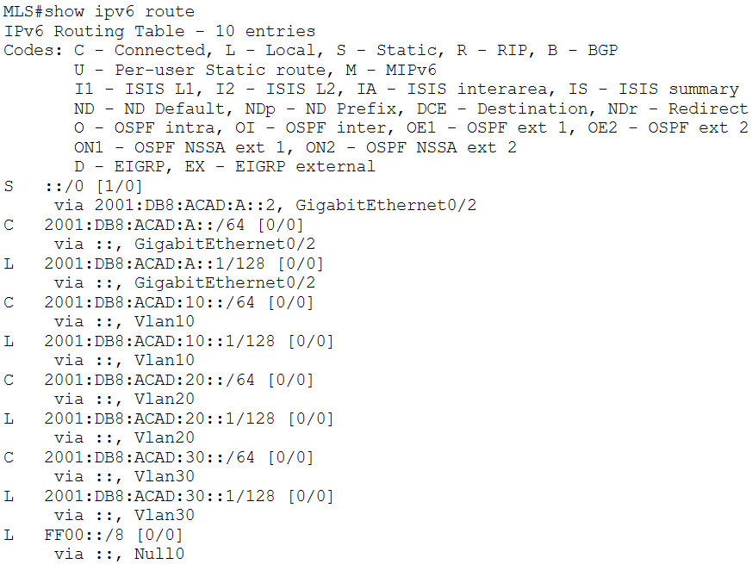
- Inter-VLAN routing and cloud connectivity was verified from PC3, PC4 and PC5.
PC3 to MLS:
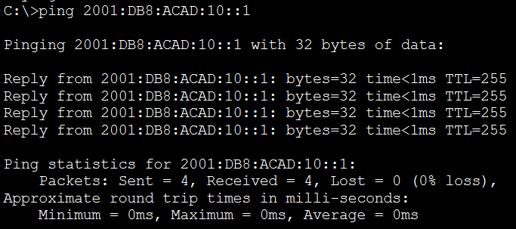
PC4 to MLS:
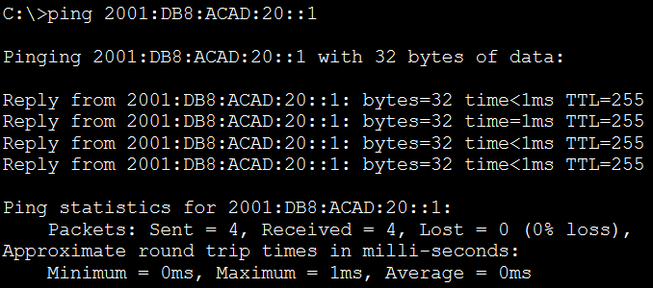
PC5 to MLS:
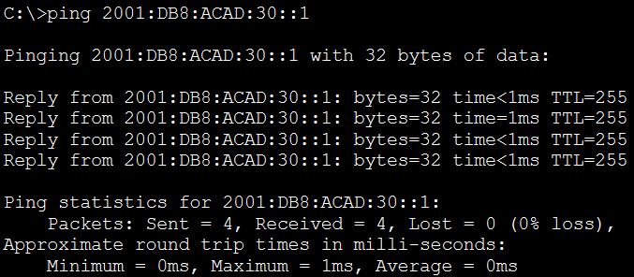
PC3 to PC4:
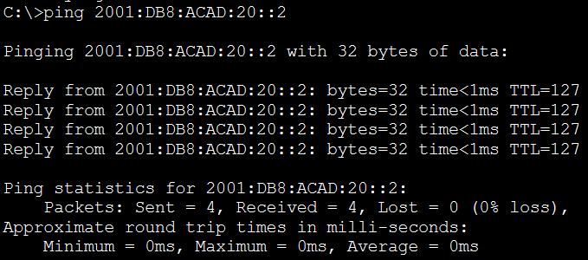
PC3 to PC5:
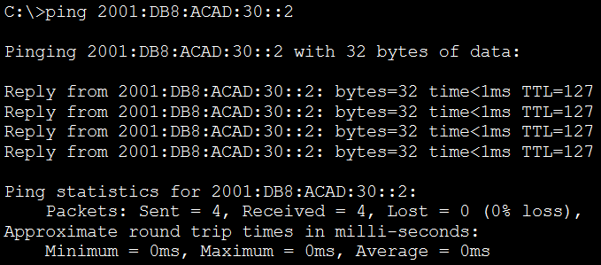
PC4 to PC5:
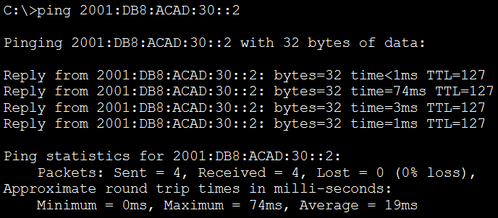
PC3 to Cloud:
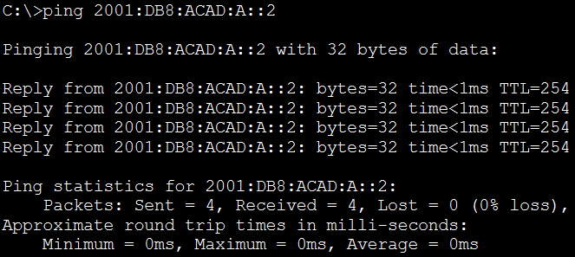

Observation:
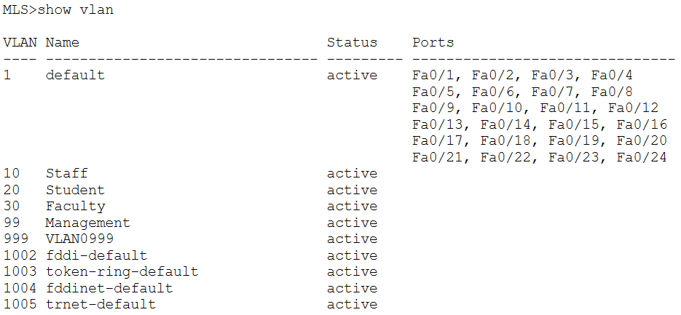
Challenges:
I believe there was a mistake in the .pka file provided for Task 1, where the Accounting server was not properly connected to the network. This led to some confusion but in the end, I decided to leave it as is, since I was unable to find a way to correct it.
There was also a small error in the second task, where an incorrect IPv6 address is shown for PC5 in the Addressing Table. This was easier to spot and fix.

